Corey McCulley  
HW 1   
8/1/20

**HW 1 – Excel Report**

1. **Given the provided data, what are three conclusions we can draw about Kickstarter campaigns?**  
   1. Most projects are in the Arts (film & television, music and theatre).
   2. The projects that were successful had the lowest average goal when compared to the failed and canceled projects (see chart) below.   
      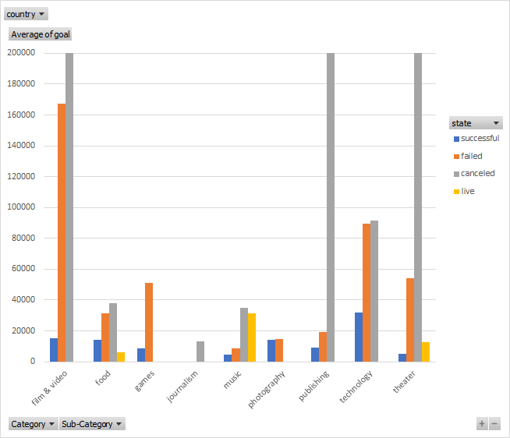  
      Similarly, the successful projects in all categories but photography, had the lowest maximum goals.   
      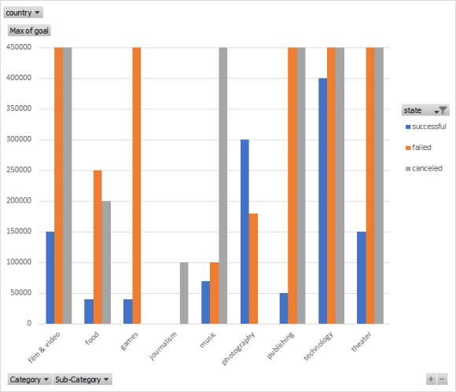  
      This information suggests that to be successful you need to have modest expectations as far as funding, and that it is rare that very expensive projects find full funding.
   3. About 75% of campaigns on kick starter are from the US.
2. **What are some limitations of this dataset?**  
   1. This data does not consider the visibility the campaign was able to achieve via marketing or tv/blog/podcast exposure.
   2. The data also doesn’t look at the different levels of funding set by the campaign. It is possible the failed campaigns set too high of an initial funding level which backers were unwilling to commit.
   3. We don’t know the total number of users on kick starter for the time each campaign was run.
   4. The data doesn’t contain how many people viewed the campaign.
3. **What are some other possible tables and/or graphs that we could create?**  
   1. It might be helpful to compare the number of backers and their average pledge between the successful/failed campaigns. This could give insight on how best adjust your goal in order to achieve funding (be successful).
   2. You could also look at the percentage of backing compared to the target goal across the different categories. Some of the projects with low goals achieved high funding percentages, so we can see that they undervalued the product/project they pitched on Kickstarter. Similarly, some projects achieved very low funding levels, so the team vastly over valued their project, had a poor pitch or had bad timing.
   3. The percent successful over time (not just by month) also should be looked into because early on kick starter was not as popular so the campaign exposure might have been limited by this.
   4. Looking at which projects were highlighted, or staff picks compared to their funding and success level, and the same for failed projects. I would expect these highlighted/staff picks to have greater success rates due to higher exposure.
   5. Comparing the length of the campaign name versus its success rate. I imagine the shorter named campaigns would have a higher success rate due to the nature of the human attention span. They are also more likely to contain buzz words that would prioritize their position in the search algorithm.
4. **BONUS – STATS ANALYSIS**
   1. **Use your data to determine whether the mean or the median summarizes the data more meaningfully.**
      1. The median is a better summary of this data set. This can be seen by the high maximum compared to the median. These high values will artificially increase the mean value and make it unrepresentative of the dataset.
   2. **Use your data to determine if there is more variability with successful or unsuccessful campaigns. Does this make sense? Why or why not?**
      1. There is more variability in the successful campaigns as seen in its high standard deviation. This high standard deviation indicates that there is a high variance from the mean in the successful campaigns. In other words, there is a large amount of spread in our data in this subcategory.